Admin

packages pages  
  
create packages  
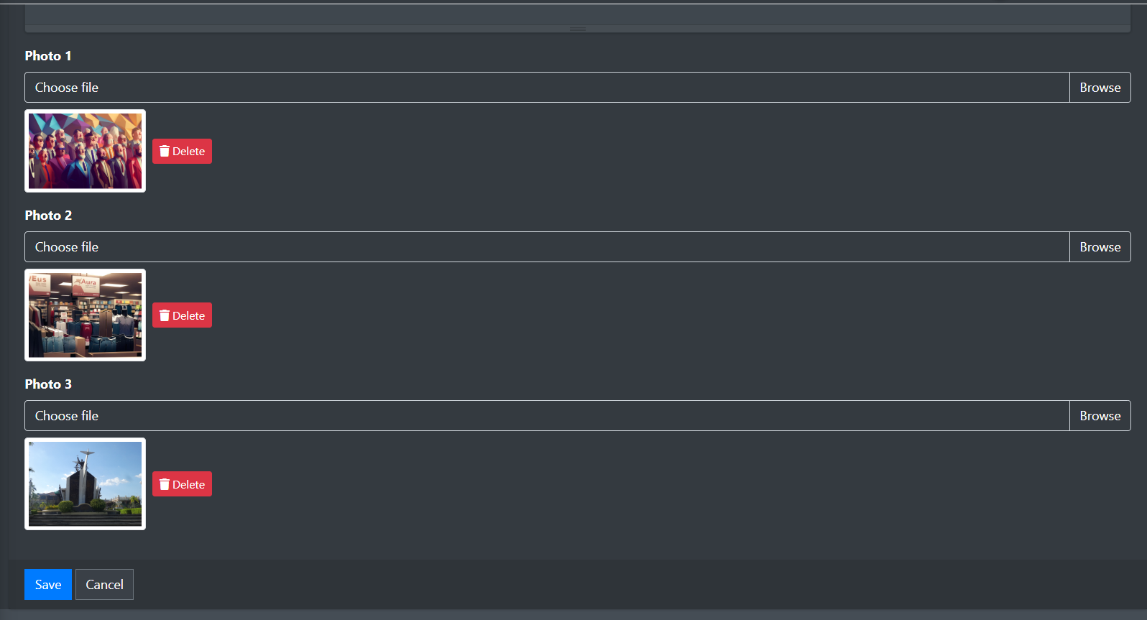  
update packages  
  
delate packages  
insert packages to product

Packages sidebar  
  
  
Landing Pages  
  
home pages  
  
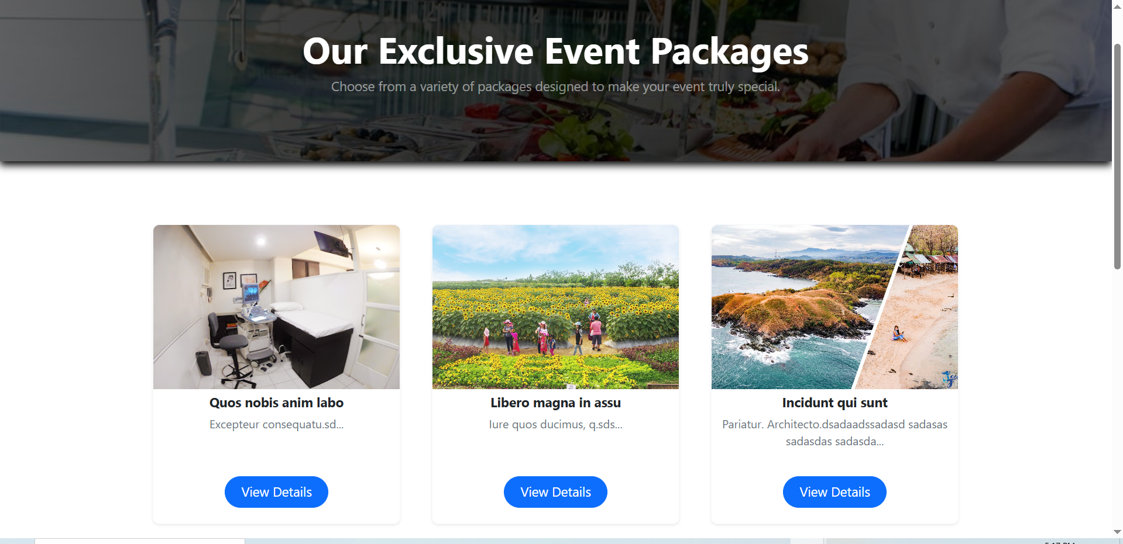  
  
packages pages

packages details pages   
  
about us pages  
  
footer